

Software Testing Assignment

**Module–1(Fundamental)**

* What is SDLC

SDLC is Software Development Life Cycle. It Is use for testing software.

* What is software testing?

Software testing is process used to identify to completeness, correctness and quality of developed computer software.

* What is agile methodology?

Agile methodology is combination of iterative and Incremental methodologies.

It is used for big project. Minor documentation.

* What is SRS

SRS is stand for software requirement specification.

SRS is documents in scope of software, role, versions, etc

* What is oops

Oops is object oriented programming language. Which are useful to make software to do some task.

* Write Basic Concepts of oops

Oops is realistic approach. Object oriented program having a six pillars,

1 object

2 class

3 encapsulation

4 polymorphism

5 abstraction

6 inheritance

* What is object

An object is define the smallest unit or entity with well define role in the software.

* What is class

Class is define as a blueprint of an object, which contain an object properties and its behavior, it will not run without declaration of an object in to main class.

* What is encapsulation

Encap means wrapping up data of an object in to single unit.

* What is inheritance

Inheritance means inheriting one class properties to another class

There are five inheritance :

1 single inheritance

2 multiple inheritance

3 multilevel inheritance

4 hierarchical inheritance

5 hybrid inheritance

* What is polymorphism

Poly – main

Morphism – form

Its allow to an object to response same massage in different way.

* Draw Usecase on Online book shopping

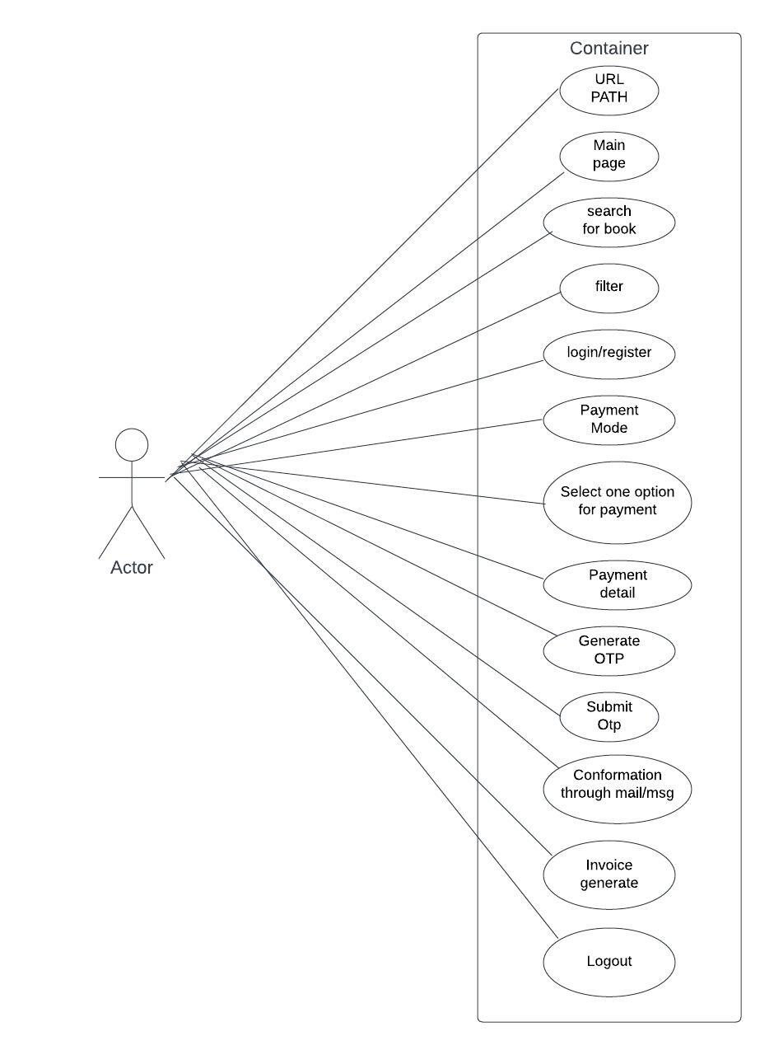

* Draw Usecase on online bill payment system (paytm)

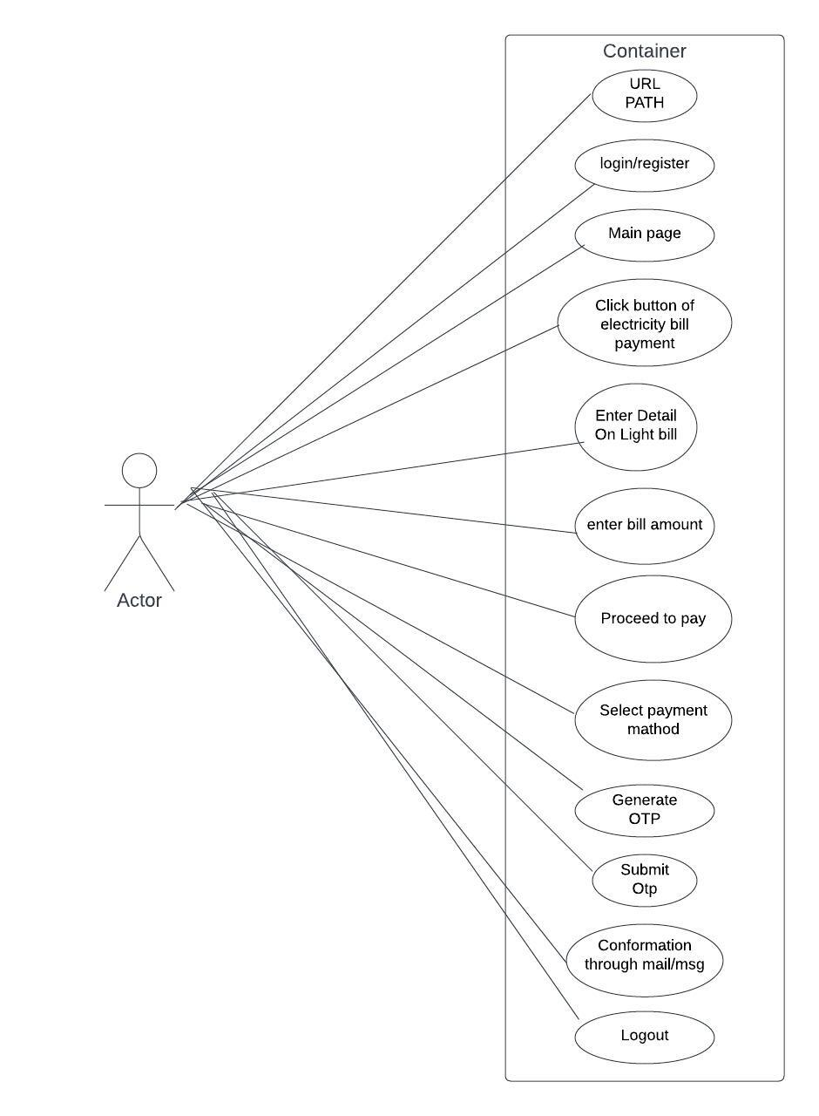

* Write SDLC phases with basic introduction

**Requirement**

**Analysis**

**Design**

**Coding**

**Testing**

**Maintenance**

* Explain Phases of the waterfall model

Waterfall model is basic model In software development life cycle.

Project is easy and simple.

Well documentation, no dynamic, no project ambiguous.

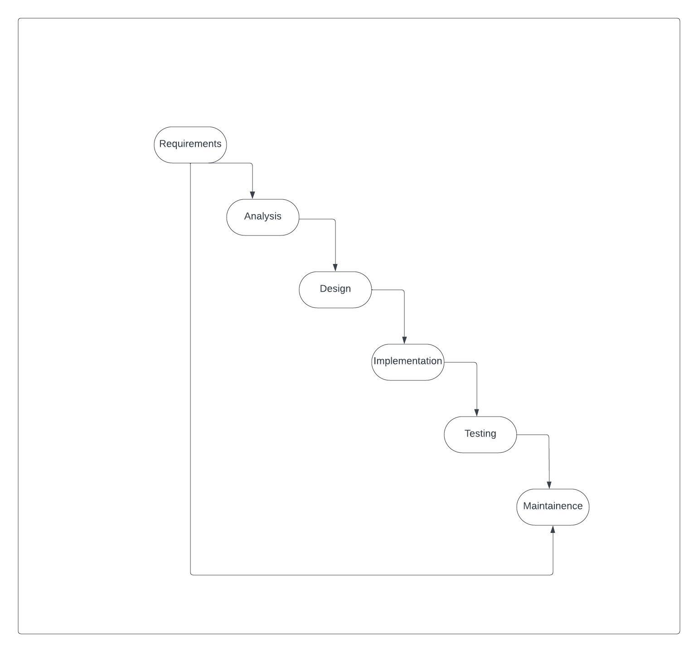

* Write phases of spiral model

Phase of spiral model

Planning

Risk analysis

Set prototype

Engineering Testing

Evaluating system

Client Base Testing

Alpha Demo

Complete criteria

In spiral model use of prototype,

Risky parts can be develop earlier,

Changing requirements and user can see the system early

* Write agile manifesto principles

It is very realistic approach

Less Documentation

* Explain working methodology of agile model and also write pros and cons.

Agile model is combination of Iterative Methodology and Incremental Methodology.

Pros.

Minimal risk and documants

Very realistic approach

Teamwork and cross training

No planning requirements

Cons.

Management complex dependency

Risky for sustainability, maintainability

Minimal Documents Generated

technology upgraded for quite challenging for Developers.

* Draw usecase on Online shopping product using COD.

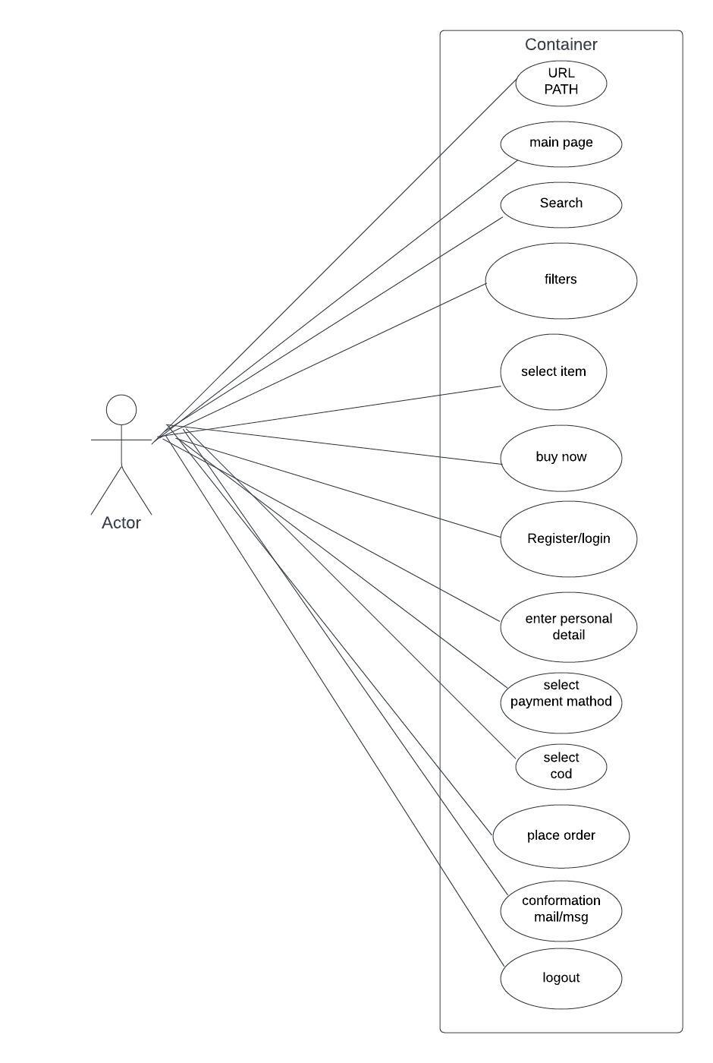

* Draw usecase on Online shopping product using payment gateway.

